Questions:
1.1 Who is a Christian and what do they believe? 1.2 Who is a Muslim and what do they believe? L2.1 What do different people believe about God? U2.1 Why do some people believe God exists? 3.1 Do we need to prove God’s existence?
Religions and worldviews:
Jewish people
Who is Jewish and what do they believe?
Key Question:
This investigation enables pupils to think about what might be found in a Jewish home and how these objects link to the Jewish way of life. There is a focus on the mezuzah, the belief in one God, Shabbat and Chanukah. Other festivals are mentioned on the planning page but this unit chooses to focus on Chanukah. This unit also has strong links with Torah, Synagogue and Pesach which pupils look at in units 1.4 and 1.5.

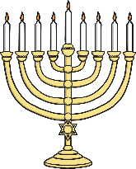

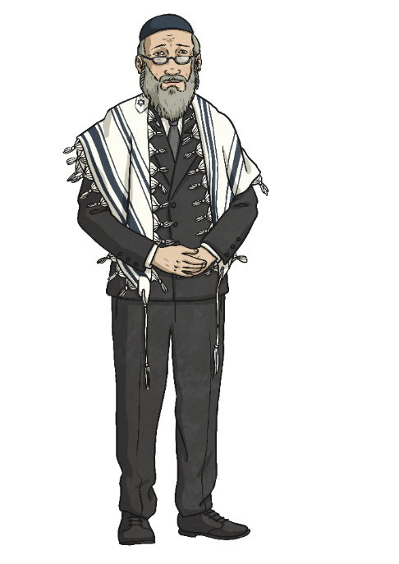
Emerging | Expected | Exceeding
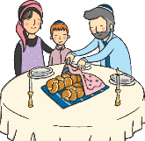  Talk about the fact that Jewish people believe in God (A1). Recognise that some Jewish people remember God in different ways  (e.g. mezuzah,  on Shabbat) (A3). | Talk about how the mezuzah in the home reminds Jewish people about God (A3).  Talk about how Shabbat is a special day of the week for Jewish people, and give some examples of what they might do to celebrate Shabbat (B1).  Re-tell a story that shows what Jewish people at the festival of Chanukah might think about God, suggesting what it means (A2). | Make links between some Jewish teachings and how Jewish people live (A2).  Express their own ideas about the value of times of reflection, thanksgiving, praise and remembrance, in the light of their learning about why Jewish people choose to celebrate in these ways (C1).
