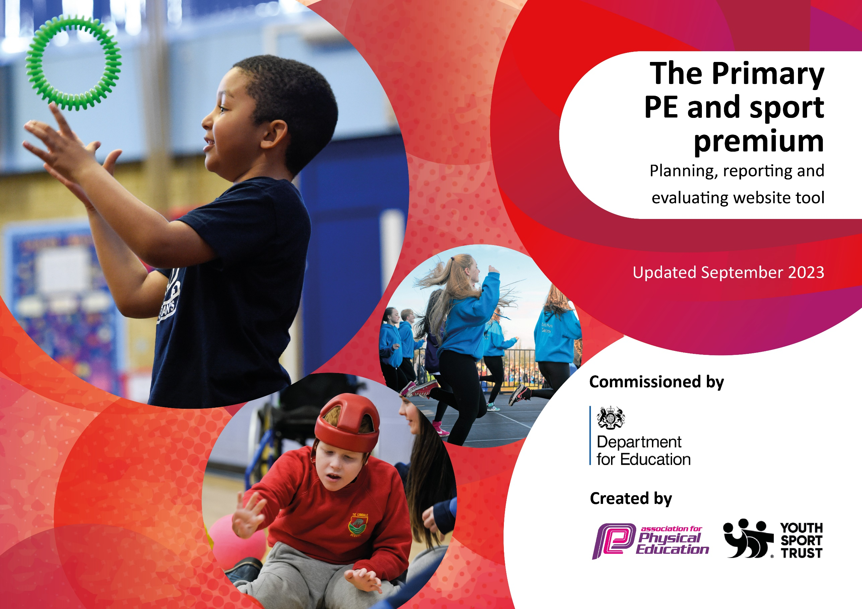

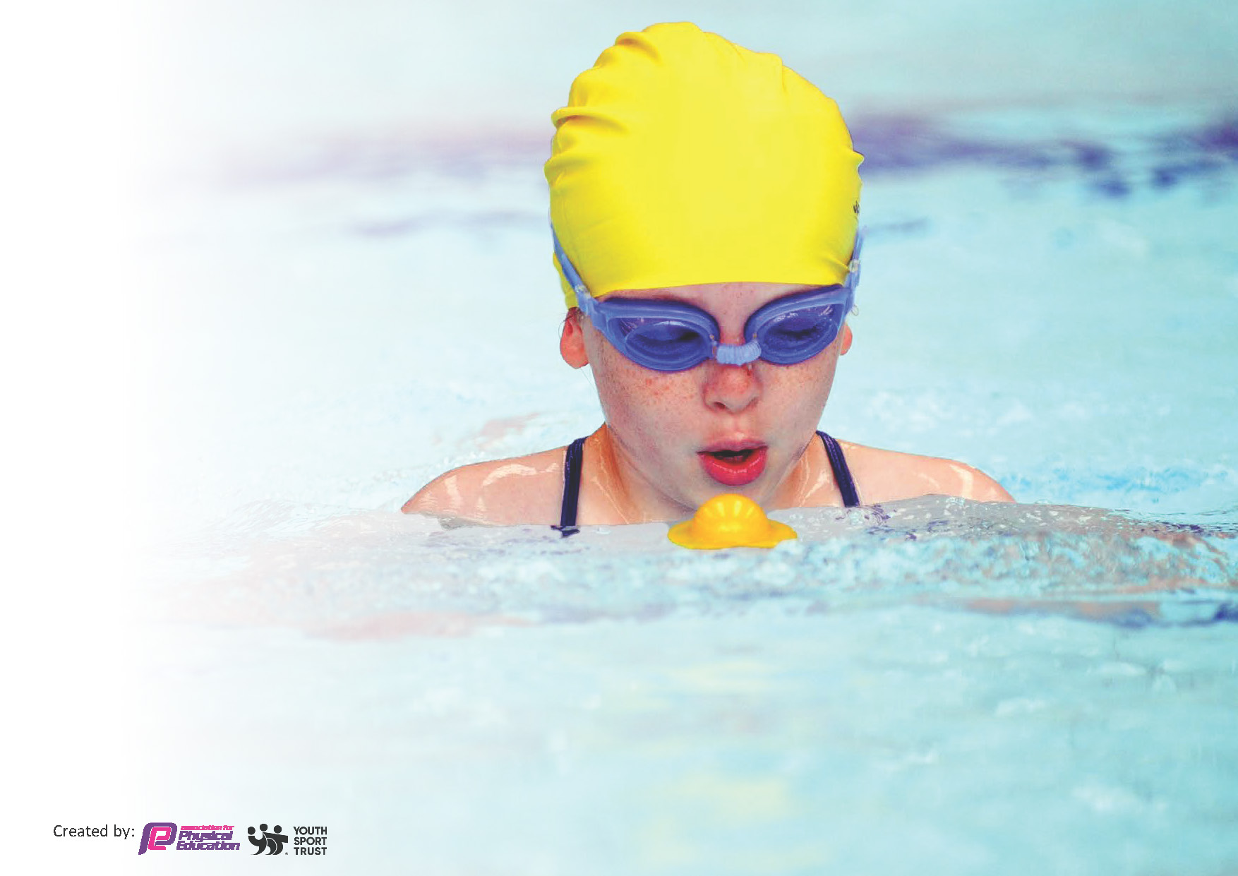
This template can be used for multiple purposes:
by:
- It enables schools to effectively plan their use of the Primary PE and sport premium
- It helps schools to meet the requirements (as set out in guidance) to publish information on their Primary PE and sport premium
- It will be an effective document to support Ofsted inspections enabling schools to evidence progress in Physical Education (PE) and evidence swimming attainment, which forms part of the PE National Curriculum. We would recommend schools consider
the Intent, Implementation and Impact of any spend, as examined within the Education Inspection Framework.

It is important that your grant is used effectively and based on school need.

Schools must use the funding to make additional and sustainable
improvements to the quality of the PE, School Sport and Physical Activity (PESSPA)
they offer. This means that you should use the Primary PE and sport premium to:

- Build capacity and capability within the school to ensure that improvements made now will benefit pupils joining the school in future years
- Develop or add to the PESSPA activities that your school already offers.

The Primary PE and sport premium should not be used to fund capital spend projects; the school’s core budget should fund these. Further detail on capital expenditure can be found in the updated Primary PE and sport premium guidance.

The Primary PE and sport premium guidance, outlines 5 key priorities that funding should be used towards. It is not

necessary that spending has to meet all the key priorities, you should select the priorities that you aim to use any funding towards.

Although completing this template is not a requirement for schools, schools are required to publish details of how they spend this funding. Schools must also outline what the impact this funding has had on pupils’ PE and sport participation and attainment and how any spending will be sustainable in the future. All funding must be spent by 31st July 2024.

The Department for Education has worked closely with the Association for Physical Education (afPE) and the Youth Sport Trust (YST) to develop this template and encourages schools to use it. This template is an effective way of meeting the reporting requirements of the Primary PE and sport premium.
Review of last year’s spend and key achievements (2022/2023)

We recommend you start by reflecting on the impact of current provision and reviewing your previous spend.

Activity/Action | Impact | Comments
Use of premier sports coaches to increase extra-curricular clubs after school.  The equipment purchased has allowed JB to extend the offer of different sports that take place either in curriculum PE lessons or after school  New St Paul’s teams kits purchased. | Over 30 extra children receiving an additional hour of physical activity when JB at other school.  Pupils experiencing a broader range of sports within school.  Children attending more events feeling confident and proud that they are representing the school | We were able to offer an additional 2 nights a week for after school clubs on Mondays and Tuesdays when JB is at other school. Next steps are to make sure different children are attending these clubs.  Equipment for sports such as Tag Rugby and the purchase of 30 yoga mats have allowed children to experience a wide range of sports  St Paul’s continue to attend EIP events each half term and continue to perform excellently.

Key priorities and Planning
This planning template will allow schools to accurately plan their spending.

Action – what are you planning to do | Who does this action impact? | Key indicator to meet | Impacts and how sustainability will be achieved? | Cost linked to the action
Pupils to attend more after school clubs and have an additional sporting group for our Friday enrichment.  Spend a large amount of money on replacing current equipment but also purchasing equipment for sports that we do not currently offer.  A large amount of our sports premium allocation is put towards our sports coach’s salary, who is responsible for all school sport and physical activity within school.  We have paid for dance workshops this year to encourage children to enjoy dance and experience different cultures | This impacts all pupils who attend St Paul’s primary school. After school clubs are open to any pupils in Year 1-6 and JB makes sure that pupils get a fair chance to attend as many as possible  Again, this impacts all pupils across years 1-6 who have a PE lesson with JB as they will be able to experience new sports from a young age.  As previously mentioned, all pupils across years 1-6 have PE lessons with JB and have the opportunity to attend after school clubs.  TA’s to be out with JB to observe and be ready to teach if JB is not here for any reason.  Full class participation. All pupils get to experience. The dance workshops are designed for all levels of dancers to be able to be involved and get the most out of the sessions. | Key indicator 2 -The engagement of all pupils in regular physical activity – the Chief Medical Officer guidelines recommend that all children and young people aged 5 to 18 engage in at least 60 minutes of physical activity per day, of which 30 minutes should be in school.  Key indicator 4: Broader experience of a range of sports and activities offered to all pupils.  Key Indicator 1: Increased confidence, knowledge, and skills of all staff in teaching PE and sport.  Key indicator 4: Broader experience of a range of sports and activities offered to all pupils. | We have seen over a 40% increase of how many pupils are attending an after school club with the additional 2 days on offer.  JB to make links and contacts with local clubs to provide a pathway for pupils who either excel or just have a passion for a certain sport. Partnerships with Salford Red Devils, Sale Sharks, Salford sports village have all provided pupils somewhere to play sport.  JB is an internal member of staff which allows him to build positive relationships with pupils. This way JB knows how to get the best out of each individual child. This may differ from some schools who use solely external providers who are in and out.  Pupils are still talking about the workshops to this date. We had 3 workshops: Diwali, Road to the Olympics and one dedicated to World Book Day. We will continue to book these in as we feel it is important for our pupils to experience different cultures of dance. | £5264  £1055.58  £7,5000  £3046.65

We continue to use 1010 as our travel partner for school. Whilst having a school minibus would be perfect this hasn’t been possible due to a number of factors.  Annual subscription to Salford School Sports partnership | Having that relationship with 1010 is crucial to the pupils’ ability to attend events away from school.  SSP has a great positive impact on everyone at the school. It allows JB to attend regular CPD events/quarterly conferences and also provides pupils with pathways in different sports | Key indicator 5: Increased participation in competitive sport.  Key Indicator 1: Increased confidence, knowledge, and skills of all staff in teaching PE and sport.  Key indicator 5: Increased participation in competitive sport. | Continue to attend as many events as possible to give pupils a positive experience of competitive sport.  This is pivotal in helping JB to shape the way PE and school sport looks at St Paul’s Primary. The CPD events allow JB to pass on info to other members of staff therefore adding extra value. | £716.63  £500

Key achievements 2023-2024
This template will be completed at the end of the academic year and will showcase the key achievements schools have made with their Primary PE and sport premium spending.

Activity/Action | Impact | Comments
The purchase of new equipment for the school has been fantastic. We bought brand new Tag Rugby equipment, 30 new yoga mats for enrichment activities and an array of other equipment.  3 Dance workshops | It has allowed pupils to try first hand new sports that they may otherwise not have had the chance to do. Pupils are using this equipment in PE lessons, extra-curricular clubs and at break and lunchtime. This is hopefully increasing the amount of physical activity that pupils at St Paul’s are taking part in.  The pupils have loved the dance workshops and it has allowed pupils to experience different cultures of dance. It is great for skills such as teamwork, with pupils working in groups to put together a routine. | I would like to increase the number of pathways for some more sports in partnership with SSP.  Next year I am sure we will continue to use these workshops throughout the year.

Swimming Data
Meeting National Curriculum requirements for swimming and water safety.
Priority should always be given to ensuring that pupils can perform safe self-rescue even if they do not fully meet the first two requirements of the National Curriculum programme of study

Question | Stats: | Further context  Relative to local challenges
What percentage of your current Year 6 cohort can swim competently, confidently and proficiently over a distance of at least 25 metres? | 43% | We were hoping to increase this number with top up swimming lessons but due to availability and closures this was not possible
What percentage of your current Year 6 cohort can use a range of strokes effectively [for example, front crawl, backstroke, and breaststroke]? | 40% | Again, we would like this to be higher but due to unforeseen circumstances that wasn’t possible.

What percentage of your current Year 6 cohort are able to perform safe self-rescue in different water-based situations? | 55% | Excellent swimming teachers at Clarendon pushed children to be able to do this even if they could not complete everything else
If your schools swimming data is below national expectation, you can choose to use the Primary PE and sport premium to provide additional top-up sessions for those pupils that did not meet National Curriculum  requirements after the completion of core lessons. Have you done this? | No | As mentioned above it was something we looked into as a school but due to transport and closures this never materialized.
Have you provided CPD to improve the knowledge and confidence of staff to be able to teach swimming and water safety? | No | All lessons are taught by qualified swimming staff. JB is on hand to provide assistance when needed as Level 1 qualified but the responsibility is with the site’s teachers.

Signed off by:

Head Teacher: | (Name)
Subject Leader or the individual responsible for the Primary PE and sport premium: | Jordan Belston – Sports Coach/Lead
Governor: | (Name and Role)
Date:

