 | 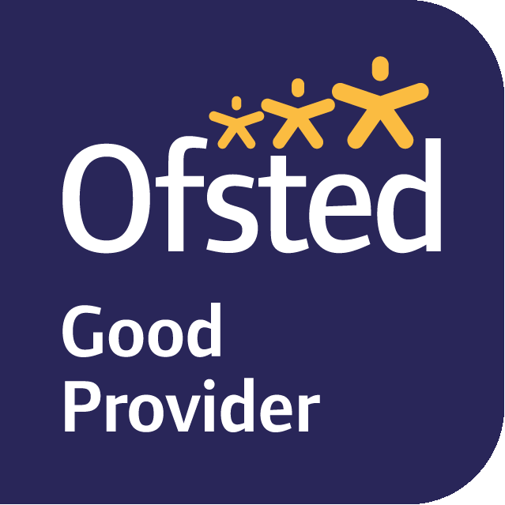 | Executive Headteacher: Mrs J. Tyers  Acting Deputy Headteacher: Mrs K Lavin  ST. PAULS C.E. PRIMARY SCHOOL  Nevile Road,  Kersal, Salford,  M7 3PT  Telephone: 0161 921 2065  Date
 | 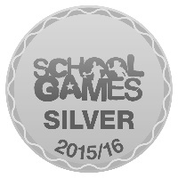

22nd November 2022

Dear parent/carer,

Re: pupil premium and free school meals

If your child is eligible for ‘free school meals’ and you register them for this, we’ll receive extra funding called ‘pupil premium’. We use this extra money to improve the educational provision and resources at the school.

What is pupil premium funding?

Pupil premium funding from the government is given to schools to help pupils reach their full potential, regardless of their background or financial situation. It’s provided for pupils who:

- Are registered for free school meals
- Have been registered for free school meals at any point in the past 6 years
- Are, or have been, in care
- Have parents in the armed forces
At St Paul’s, we get extra funding for every eligible pupil who is registered for free school meals. This extra money could make a real difference to the quality of education we offer.

For example, we’ve previously used pupil premium funding for:

- Educational provision/resources/visits
- Academic interventions
- Classroom support
- Wellbeing and self-esteem building interventions

Is my child eligible for free school meals?

Your child might be eligible if you access:

- Income Support
- Income-based Jobseeker’s Allowance or Employment and Support Allowance
- Support under part VI of the Immigration and Asylum Act 1999
- The guaranteed element of Pension Credit
- Child Tax Credit (provided you’re not also entitled to Working Tax Credit and have an annual gross income of no more than £16,190)
- Working Tax Credit run-on
- Universal Credit, provided you have an annual net earned income not exceeding £7,400 (£616.67 per month)

Universal infant free school meals

Currently, pupils in reception, year 1 and year 2 are entitled to a free school meal thanks to a different government funding scheme known as universal infant free school meals (UIFSM). You shouldn’t confuse UIFSM with free schools meals and the pupil premium.

If your child is in reception, year 1 or year 2 and is eligible for free school meals according to the criteria above, you should still register because we’ll receive the extra pupil premium funding.

Does my child have to eat the free school meals?

No. Pupils who are registered for free school meals don’t have to eat them. If you’re eligible but you want your child to have packed lunches you should still register because the school will receive the funding which can support your child in other ways.

How do I register?

To register online please follow the link below :-

https://www.salford.gov.uk/schools-and-learning/free-school-meals/

To register by phone please call please :- 0161 793 2500

More information

For more information about pupil premium go to our website, which contains details of how the pupil premium has been spent in the past academic year and how it will be spent this year.

If you have any questions or specific concerns, please contact Mrs Thomas or enquire in the school office.

Best wishes,

Mrs T Kehoe
School Business Manager

