Questions:
F5: Where do we belong? 1.7 What does it mean to belong to a faith community? L2.7 What does it mean to be a Christian in Britain today? U2.6 What does it meant to be a Muslim in Britain today? 3.8 What is good and what is challenging about being a teenage Buddhist, Sikh or Muslim in Britain today
Religions and worldviews:
Hindus
What does it mean to be a Hindu in Britain Today?
Key Question:
This investigation enables pupils to learn about key aspects of Hindu belief and worship. What we call ‘Hinduism’ is the diverse way of life, spiritual practices and beliefs of the Indian people. We are focussing on British Hindus, and there is great diversity in British Hinduism as well as the original Indian Hinduism. Hinduism is more appropriately called ‘Sanatana Dharma’; eternal truth. We will find out some key Hindu beliefs, and how these are expressed in thoughts and actions. We will also think about being a Hindu in Britain today.
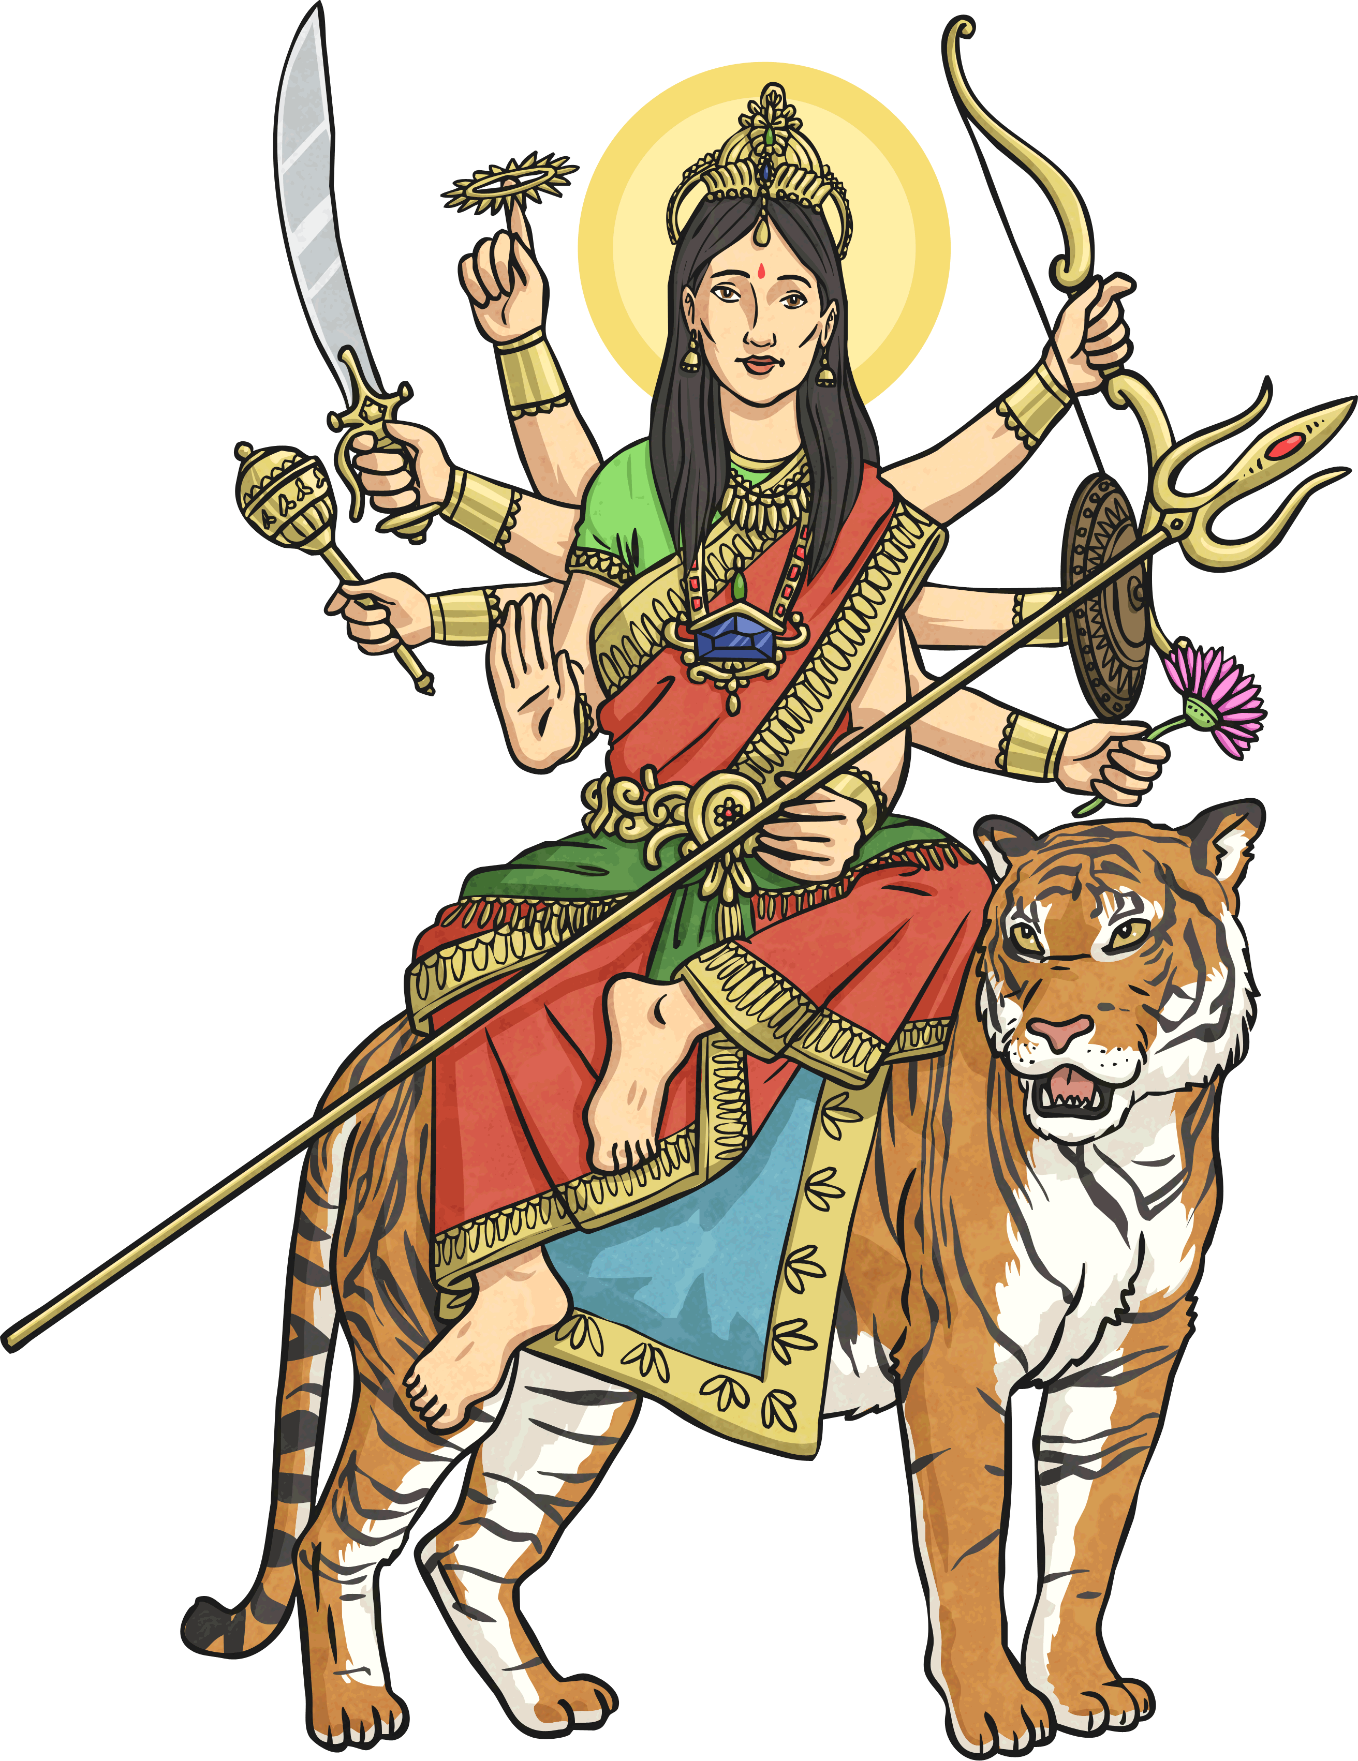
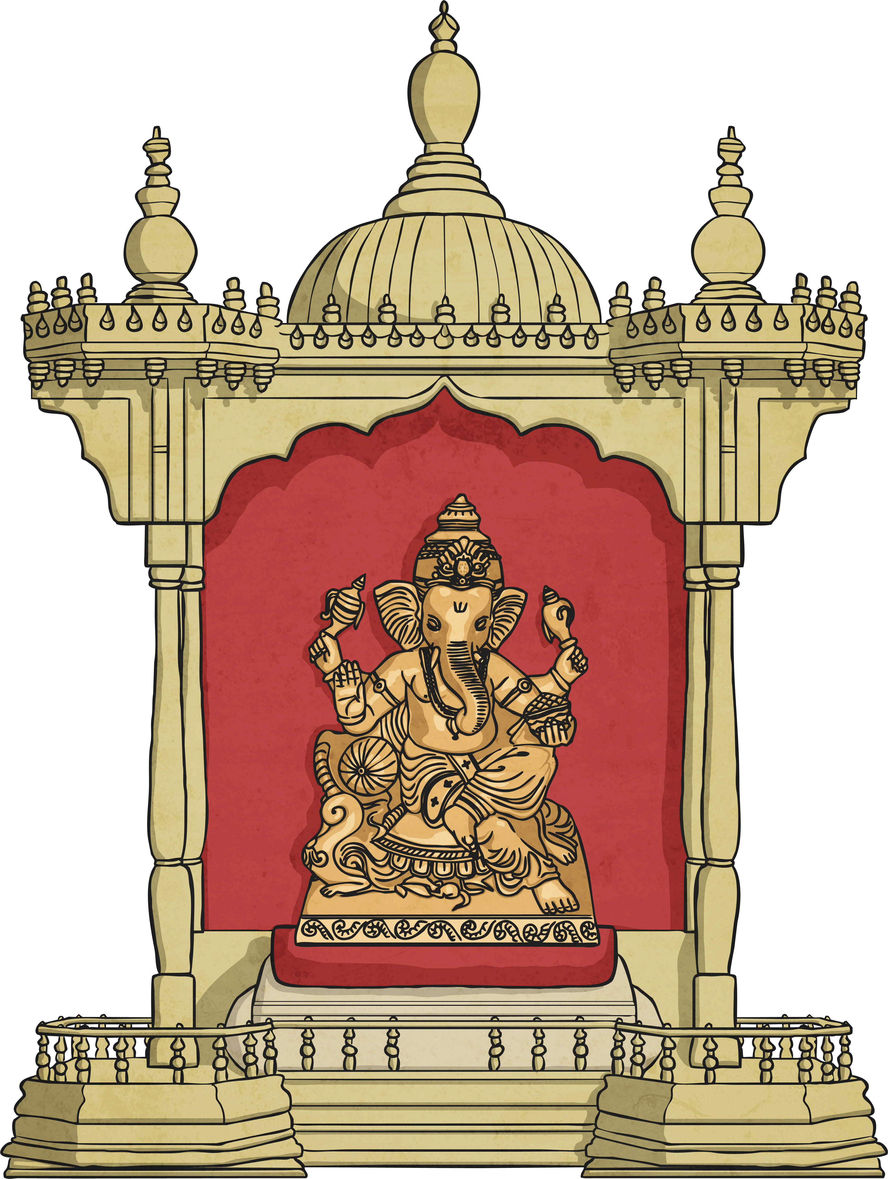
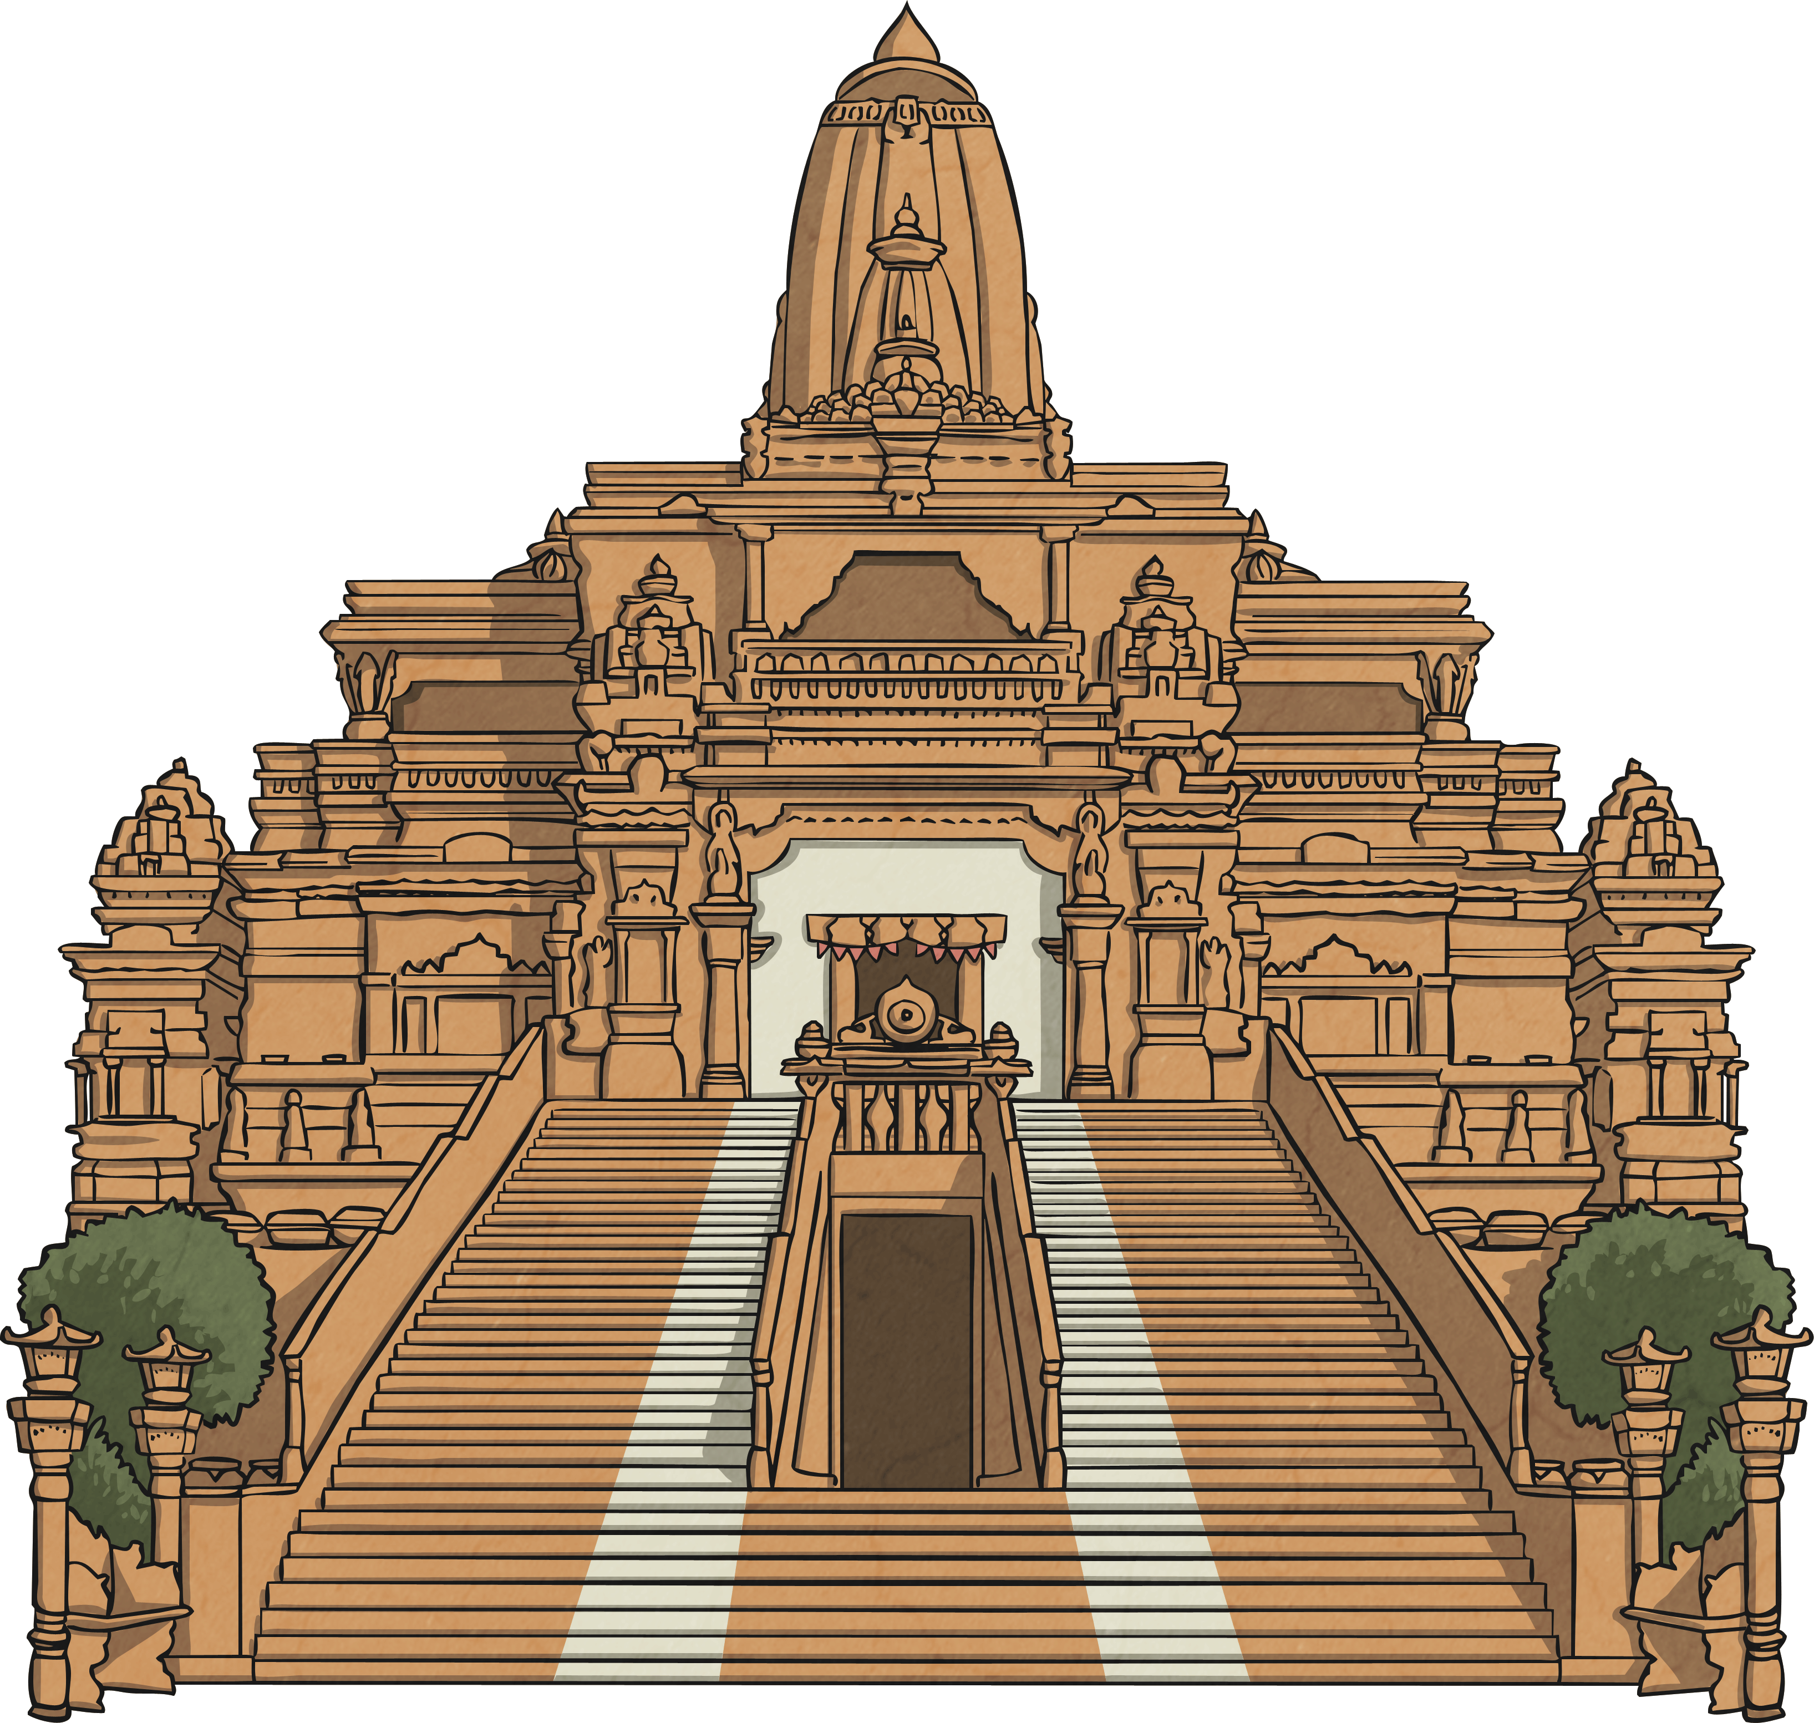
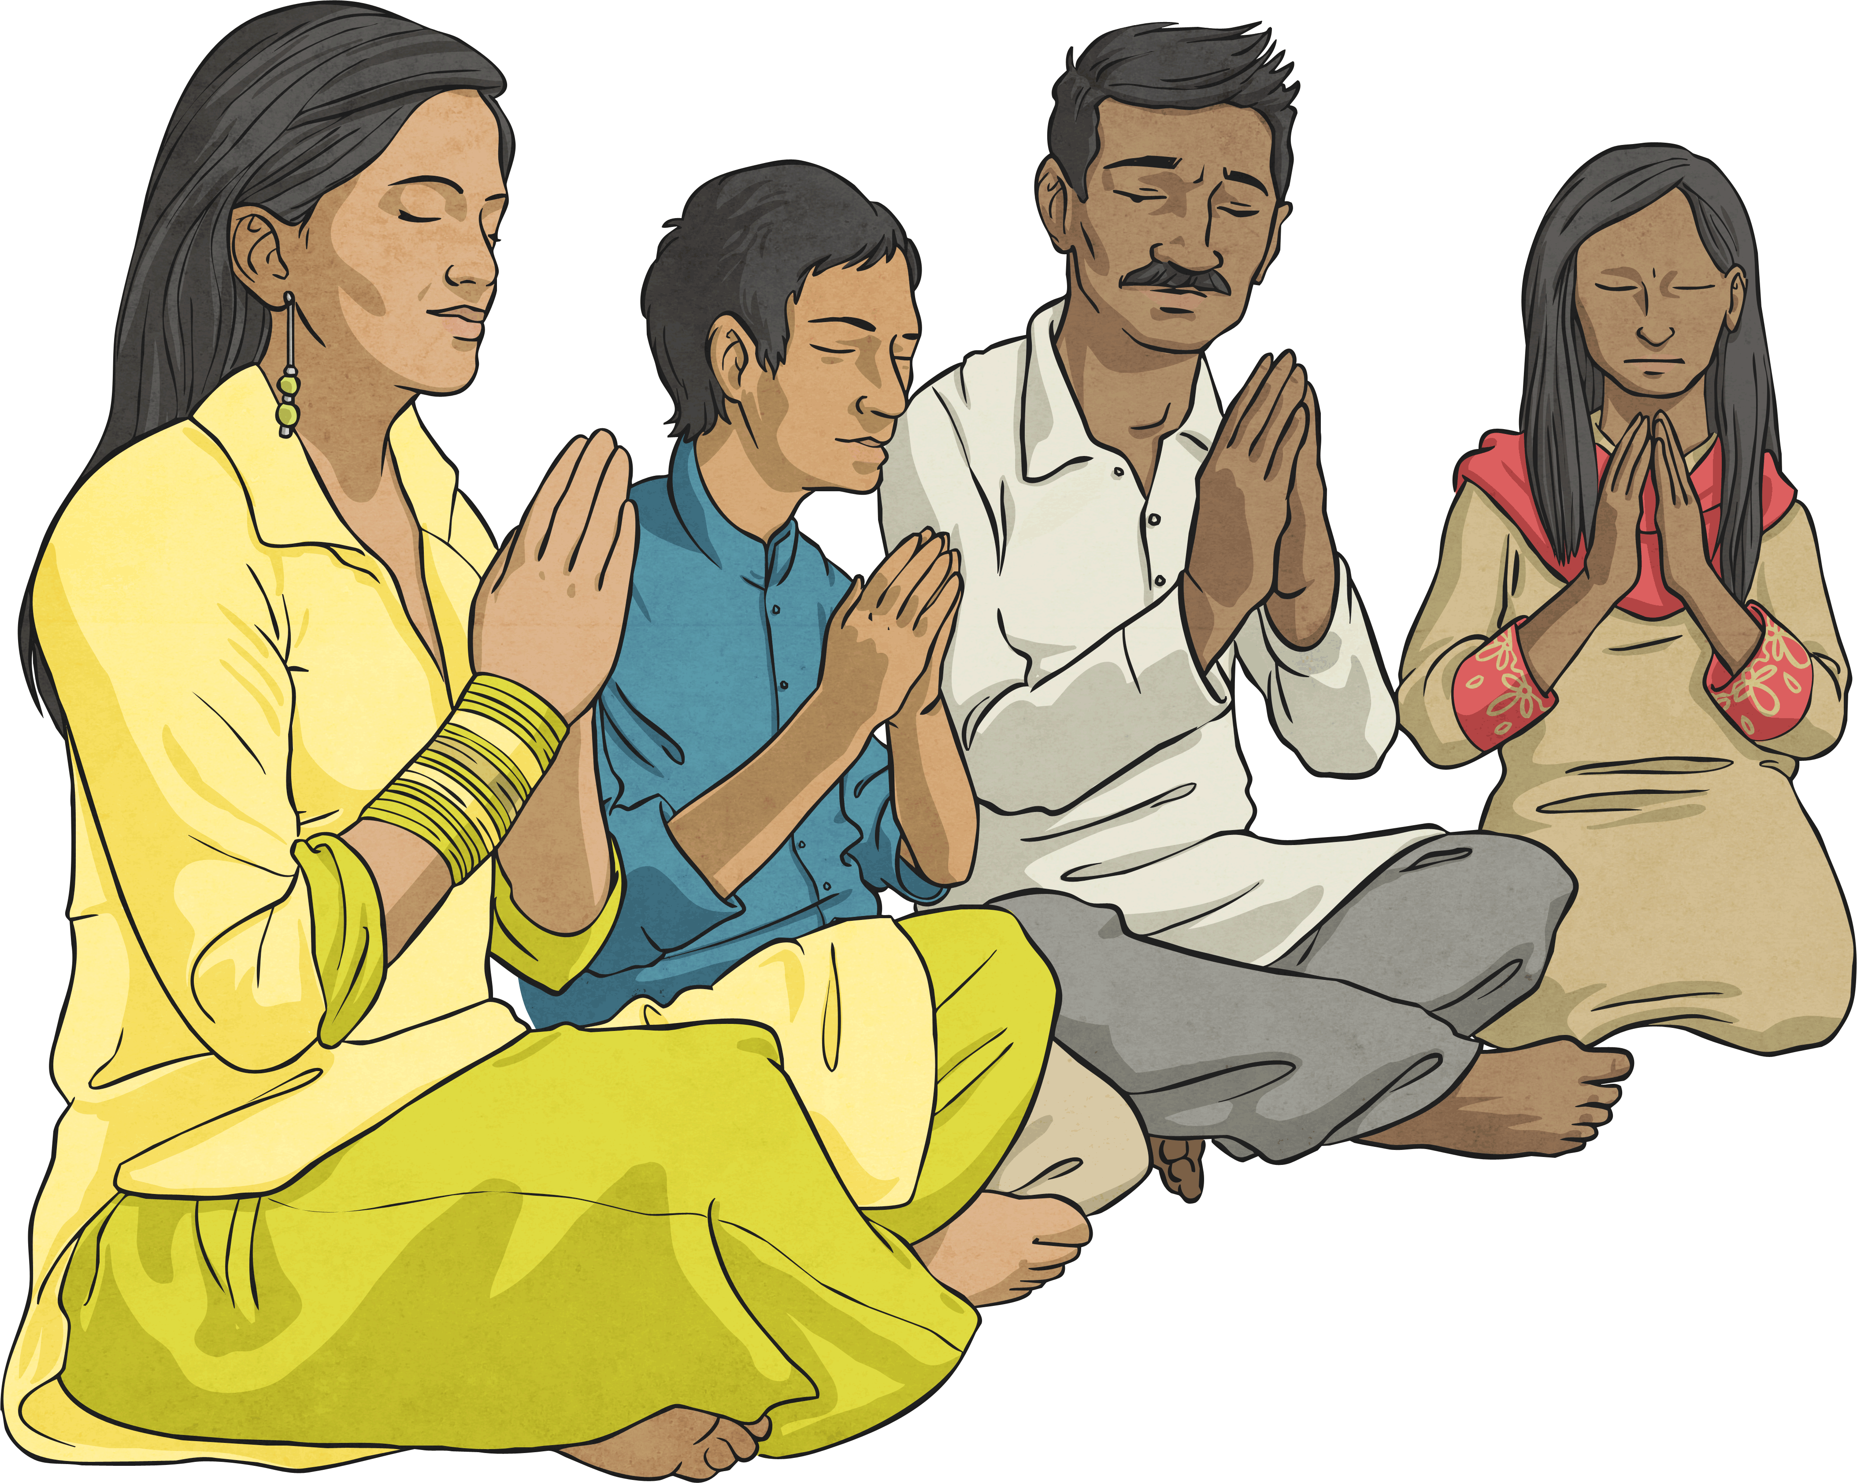
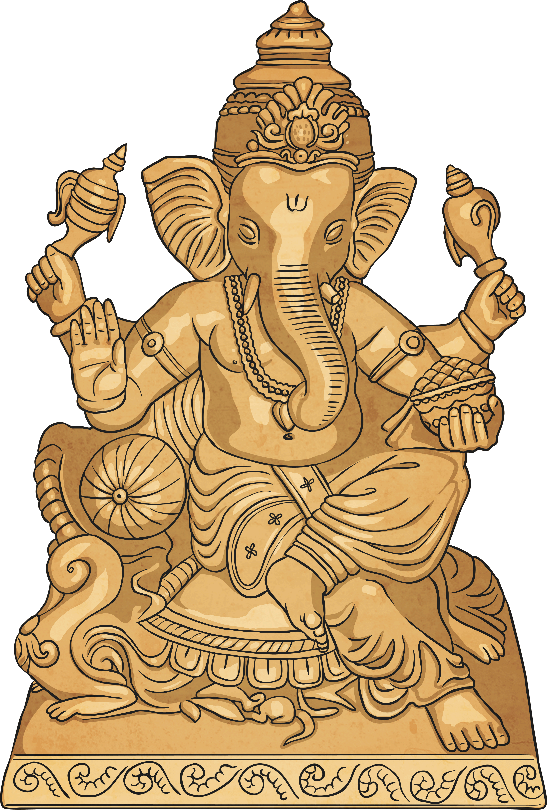
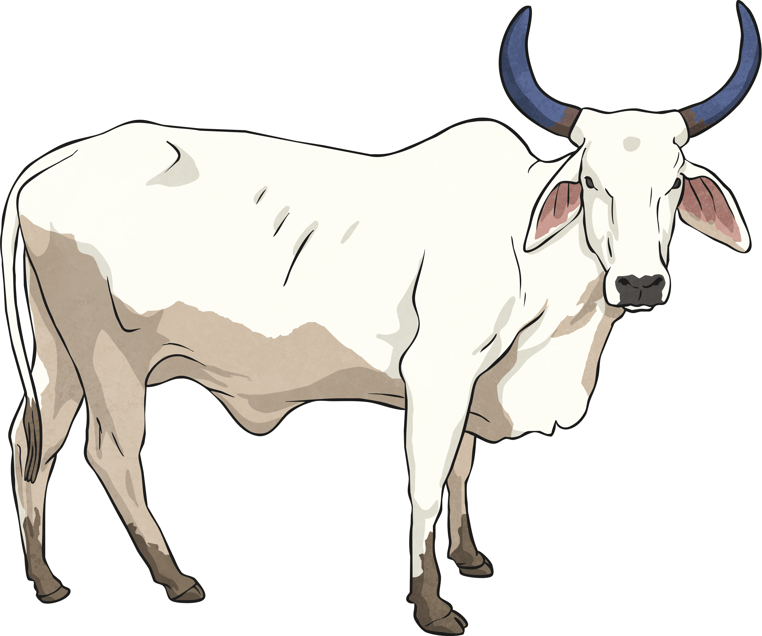
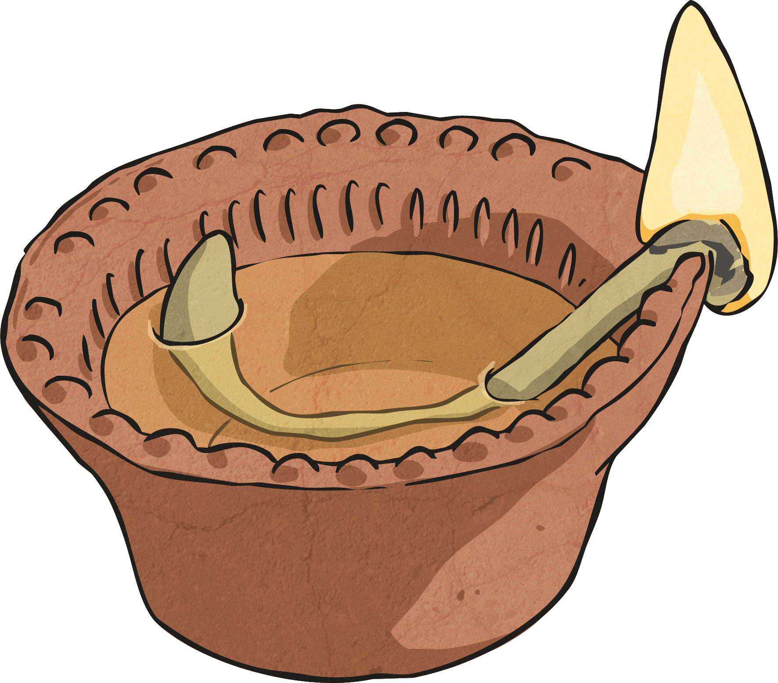
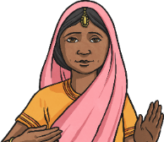

Emerging | Expected | Exceeding
Identify and name examples of what Hindus have and do in their families and at mandir to show their faith (A3).  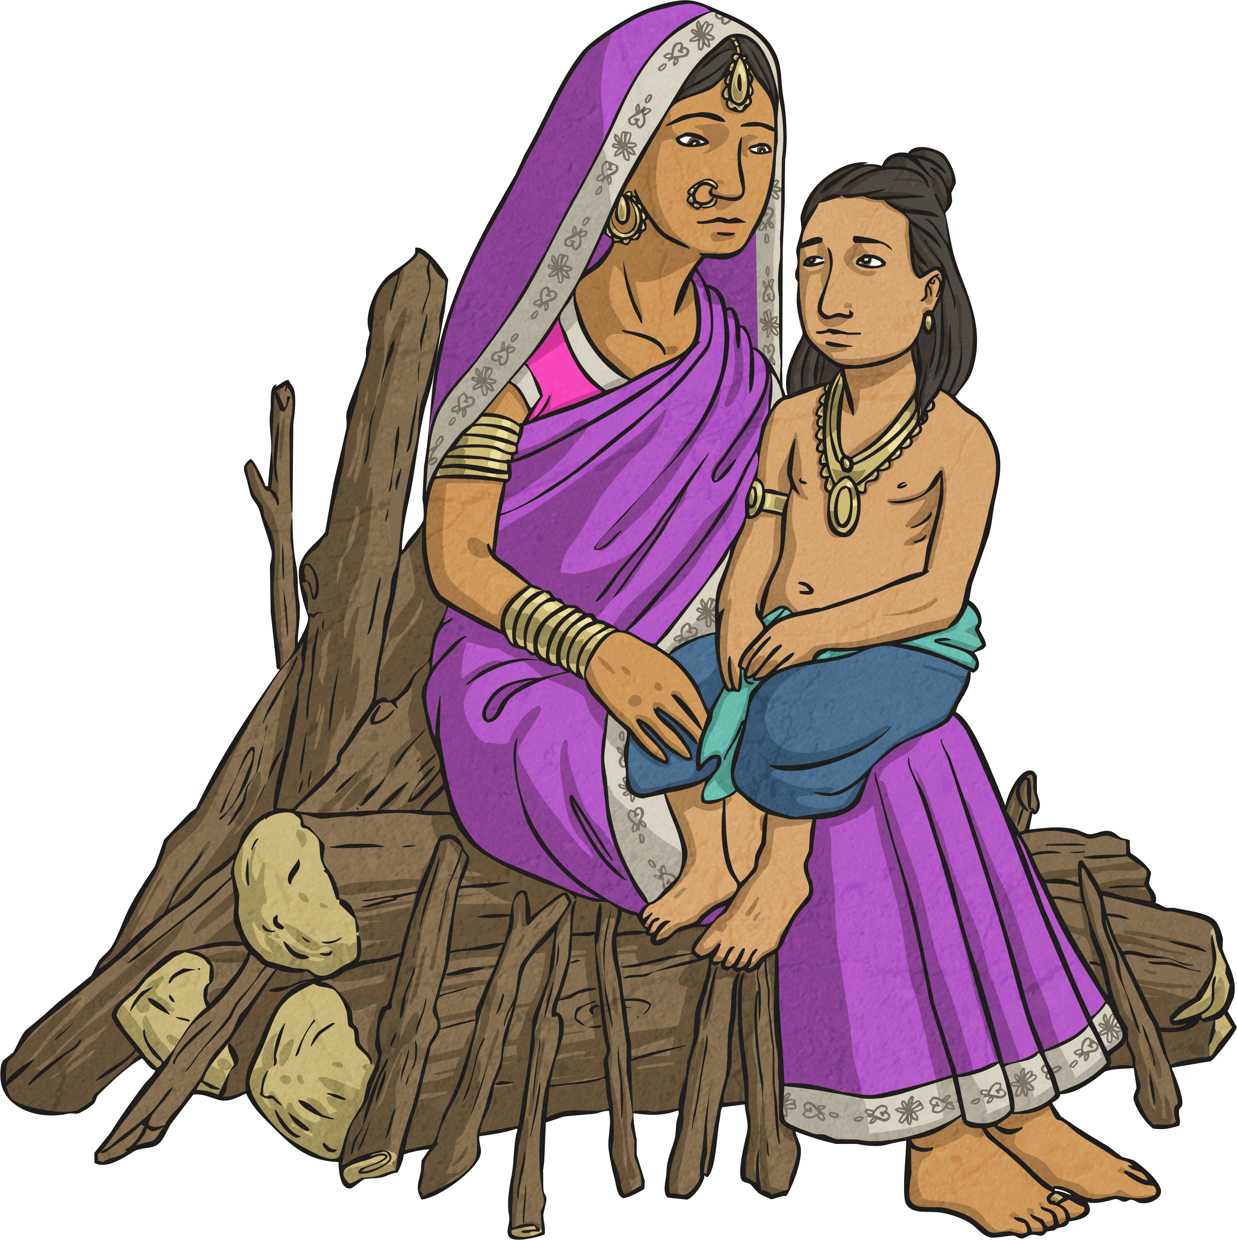  Ask good questions about what Hindus do to show their faith (B1). | 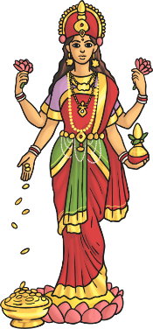  Describe some examples of what Hindus do to show their faith, and make connections with some Hindu beliefs and teachings about aims and duties in life (A1).  Describe some ways in which Hindus express their faith through puja, aarti and bhajans (A2).  Suggest at least two reasons why being a Hindu is a good thing in Britain today, and two reasons why it might be hard sometimes (B2).  Discuss links between the actions of Hindus in helping others and ways in which people of other faiths and beliefs, including pupils themselves, help others (C2) | Explain similarities and differences between Hindu worship and worship in another religious tradition pupils have been taught (B3).  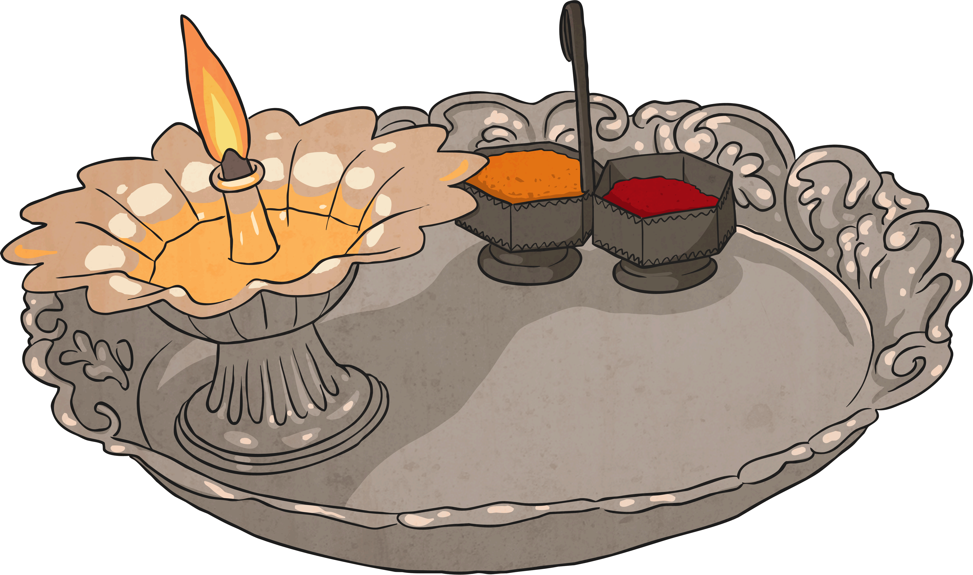  Discuss and present ideas about what it means to be a Hindu in Britain today, making links with their own experiences (C1).

