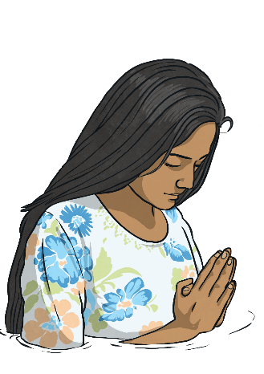
Questions:
F3 Which places are special and why? 1.5 What makes some places sacred? U2.4 If God is everywhere, why go to a place of worship? 3.6 Should religious buildings be sold to feed the starving?
Religions and worldviews:
Hindus, Christians and Muslims

Why do people pray?
Key Question:
This investigation enables pupils to learn in depth from different religious and spiritual ways of life about prayer: the practice, symbols, words and significance of prayer are studied alongside some key beliefs about prayer, so that pupils can develop thoughtful ideas and viewpoints of their own about prayer.

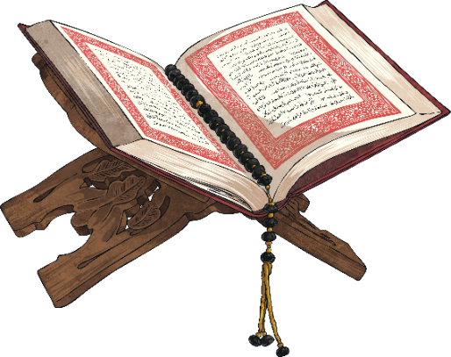
Our Father, who art in heaven,
Hallowed be thy Name.
Thy Kingdom come.
Thy will be done,
On Earth as it is in heaven.
Give us this day our daily bread.
And forgive us our trespasses,
As we forgive them that trespass
against us.
And lead us not into temptation,
But deliver us from evil.
For thine is the kingdom,
The power, and the glory,
For ever and ever.
Amen.
Emerging | Expected | Exceeding
Describe what some believers say and do when they pray (A1).  Respond thoughtfully to examples of how praying helps religious  believers (B2). | Describe the practice of prayer in the religions studied (A2). Make connections between what people believe about prayer and what they do when they pray (A3)  Describe ways in which prayer can comfort and challenge believers (B2).  Describe and comment on similarities and differences between how Christians, Muslims and Hindus pray (B3). | Explain similarities and differences between how people pray (B3).  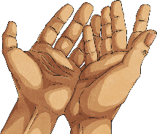  Consider and evaluate the significance of prayer in the lives of people today (A1).
