What do religions say to us when life gets hard?
Key Question:
This investigation enables pupils to learn in depth from different religious and spiritual ways of life about teaching about hard times, focussing on exploring death. We have exemplified the unit in this way as we are aware that this is a difficult but essential topic for teachers to explore with children. By the age of 10 many children will have experienced grief and death. This unit allows them to talk about these ideas when emotions are less raw than after a bereavement. The activities enable pupils to share their ideas but do not force children to do so. The use of story acts as a distancing device within the unit. Ensure that you have considered any pupils who have experienced a difficult or traumatic family event, or have experienced loss within their family. As well as the preparation letter, contact particular families and seek their advice if in any doubt. This unit is designed as an enquiry based unit which may be taught over a series of weeks or in a shorter, more concentrated period such as during an RE week. It is impossible to write a pure child led enquiry this way and so the unit assumes some questions your pupils might choose to investigate and suggests ways to investigate them. What you do in this unit will depend on the questions generated by the children in your class.
Questions:
3.4 Is death the end? Does it matter? 3.5 Why is there suffering? Are there any solutions?
Religions and worldviews:
Christians, Hindus, Muslims and Humanists

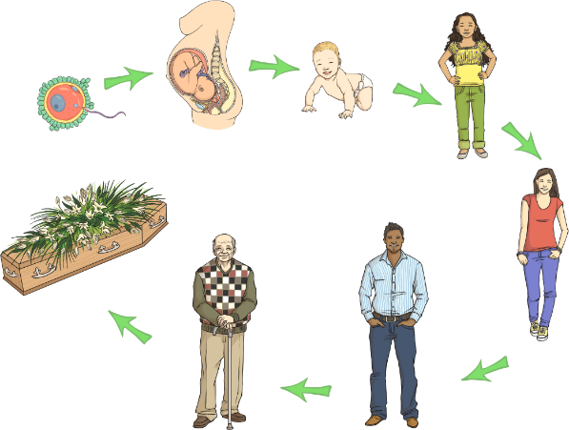

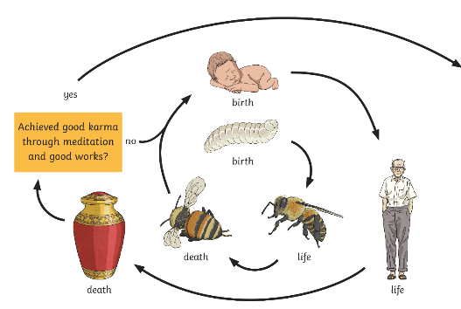

Emerging | Expected | Exceeding
Raise thoughtful questions and suggest some answers about life, death, suffering, and what matters most in life (B1).  Give simple definitions of some key terms to do with life after death, e.g. salvation, heaven, reincarnation (A3). | Express ideas about how and why religion can help believers when times are hard, giving examples (B2).  Outline Christian, Hindu and/or nonreligious beliefs about life after death (A1).  Explain some similarities and differences between beliefs about life after death (B2).  Explain some reasons why Christians and Humanists have different ideas about an afterlife (B3). | Explain what difference belief in judgement/heaven/karma/ reincarnation might make to how someone lives, giving examples (B1).  Interpret a range of artistic expressions of afterlife, offering and explaining different ways of understanding (B3).

