What does it mean to be a Christian in Britain today?
Key Question:
This investigation enables pupils to learn in depth from different religious and spiritual ways of life about what Christians do at home, in church and in the wider community and why these things are important to them.
Questions:
F5 Where do we belong? 1.7 What does it mean to belong to a faith community? L2.8 What does it mean to be a Hindu in Britain today? U2.6 What does it meant to be a Muslim in Britain today? 3.8 What is good and what is challenging about being a teenage Buddhist, Sikh or Muslim in Britain today?
Religions and worldviews:
Christians

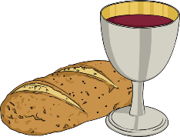
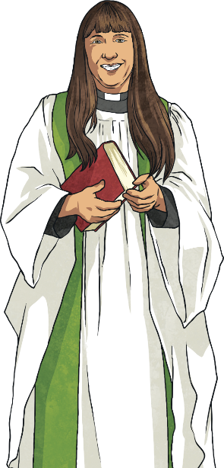
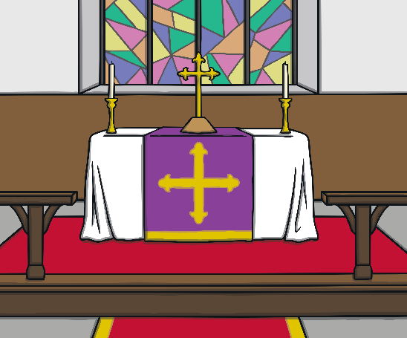
Our Father, who art in heaven,
Hallowed be thy Name.
Thy Kingdom come.
Thy will be done,
On Earth as it is in heaven.
Give us this day our daily bread.
And forgive us our trespasses,
As we forgive them that trespass against us.
And lead us not into temptation,
But deliver us from evil.
For thine is the kingdom,
The power, and the glory,
For ever and ever.
Amen.
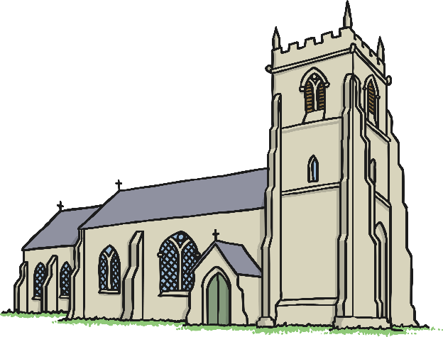
Emerging | Expected | Exceeding
Identify and name examples of what Christians have and do in their families and at church to show their faith (A3).  Ask good questions about what Christians do to show their faith (B1) | Describe some examples of what Christians do to show their faith, and make connections with some Christian beliefs and teachings (A1).  Describe some ways in which Christian express their faith through hymns and modern worship songs (A2).  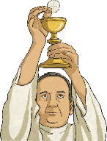  Suggest at least two reasons why being a Christian is a good thing in Britain today, and two reasons why it might be hard sometimes (B2).  Discuss links between the actions of Christians in helping others and ways in which people of other faiths and beliefs, including pupils themselves, help others (C2). | Explain similarities and differences between at least two different ways of worshipping in two different Christian churches (A3). • Discuss and present ideas about what it means to be a Christian in Britain today, making links with their own experiences (C1)
