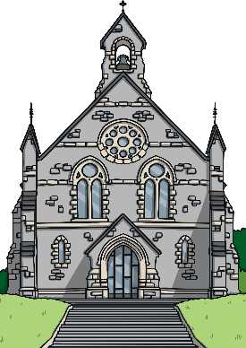
Questions:
F3 Which places are special and why?
L2.4 Why do people pray?
U2.4 If God is everywhere, why go to a place of worship?
3.6 Should religious buildings be sold to feed the starving?
Religions and worldviews: Christians, Muslims and/or Jewish people
What makes some places sacred?
Key Question: This investigation enables pupils to learn in depth from different religious and spiritual ways of life about places of worship for Christians and either Jewish people or Muslims. Within the unit teachers should plan for a visit to the two places of worship being studied if at all possible. Pupils will have the opportunity to act as detectives answering their own questions about places of worship, what they are used for and their significance in the local community.
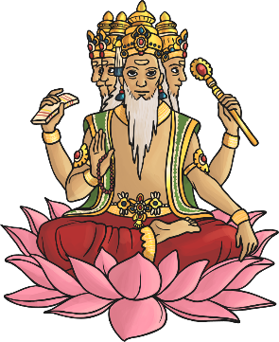

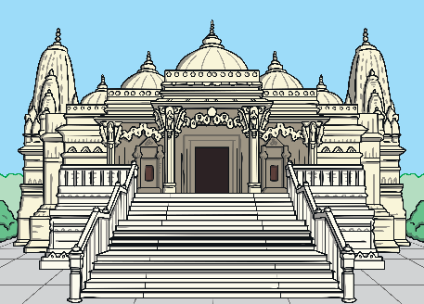
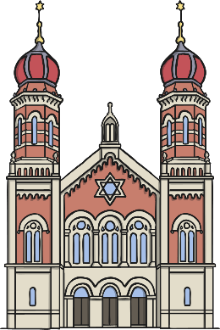

Emerging | Expected | Exceeding
Recognise that there are special places where people go to worship, and talk about what people do there (A1).  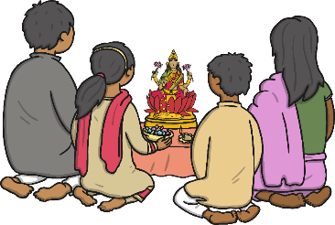  Identify at least three objects used in worship in two religions (A3). | Identify special objects and symbols found in a place where people worship and be able to say something about what they mean and how they are used (A3).  Talk about ways in which stories, objects, symbols and actions used in churches, mosques and/or synagogues show what people believe (B2).  Ask good questions during a school visit about what happens in a church, synagogue or mosque (B1). | 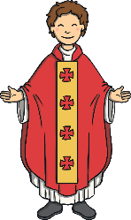  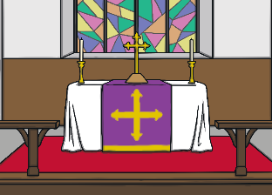  Show that they have begun to be aware that some people regularly worship God in different ways and in different places (B3).
